# 

# Discussion Paper 1

Housing As A Base for Life

## THE CHALLENGE

1. Secure housing, a fundamental human right, is the foundation for sound health, good educational outcomes, and the chance to work and enjoy the benefits available to other Australians.
2. Secure housing enriches spiritual wellbeing and provides a platform for building emotional security and financial stability.
3. Despite this it has not received primacy in Government policy and has not been a priority for Government investment.
4. Major national policies such as Closing the Gap (CTG) lack ambition on housing; limited to a single housing target on overcrowding which Victoria is already meeting while homelessness rates continue unabated. This is despite the fact that many other CTG targets depend on better housing for their attainment. The failure to set an even moderately ambitious housing target matters because, if anything is likely to drive Government investment, it is targets for which Government and the community share accountability and must report transparently.

|  |
| --- |
| **Closing the Gap Targets That Depend on More and Better Housing**   * 1. **Target 3:** By 2025, increase the proportion of Aboriginal and Torres Strait Islander children enrolled in Year Before Fulltime Schooling (YBFS) early childhood education to 95 per cent.      1. ***Barriers to attendance (including housing)***   2. **Target 7:** By 2031, increase the proportion of Aboriginal and Torres Strait Islander youth (15-24 years) who are in employment, education or training to 67 percent.      1. ***Barriers to youth engagement (including homelessness)***   3. **Target 10:** By 2031, reduce the rate of Aboriginal and Torres Strait Islander adults held in incarceration by at least 15 per cent.      1. ***proportion of offenders denied bail/parole by type of offence and reason for denial (including lack of accommodation)***   4. **Target 11:** By 2031, reduce the rate of Aboriginal and Torres Strait Islander young people (10-17 years) in detention by at least 30 per cent.      1. ***Proportion of young people in detention who had received specialist homeless support services***   5. **Target 13:** A significant and sustained reduction in violence and abuse against Aboriginal and Torres Strait Islander women and children towards zero.      1. ***Proportion seeking assistance from Specialist Homelessness Services for reasons of domestic/family violence.*** |

1. The Framework has sought to embed housing objectives, actions and targets across all major Aboriginal reform strategies. AHV has made submissions to major policy reform projects in portfolios across Government to reinforce the centrality of housing to achievement of other human outcomes for our people.
2. In addition, where we have a network of Aboriginal social housing this provides a foundation from which to deliver critical support programs. Social housing has the potential to be an integrated program delivery platform from which we can measurably reduce Aboriginal inequality and disadvantage.
3. In the wider service system, models of capital investment in housing rarely include wrap around services to address the multiple challenges many people living in social housing are managing. Without these support services to improve mental health, deal with alcohol and drug issues and provide a bridge to employment, tenancies cannot always be sustained.
4. Homeless Aboriginal people in Victoria continue to be far less likely to have case plans in place than Aboriginal people in other parts of Australia (45% versus 55%[1]). The reforms proposed by the ***Blueprint for an* *Aboriginal-specific Homeless System in Victoria***, developed by AHV with KPMG would address this persistent weakness in the Victorian SHS.
5. One of the great strengths of ACCOs is that they deliver integrated, trauma-informed services to First Peoples in culturally safe ways. They require more support to do so on a wider scale and to build more housing around which human services can be wrapped to support tenants.
6. Through its pilot program *More Than a Landlord*, AHV has also demonstrated the efficacy of providing human services to Aboriginal people living in social housing. The delivery period of the program has been extended but its scale remains modest and with greater investment, it has the potential to help many Aboriginal families.

|  |
| --- |
| The Victorian Government’s 2018 Re-election Platform made this commitment:  ***“Labour will …enable organisations providing housing to provide Aboriginal-specific case management support services, including for Aboriginal Victorians on waiting lists and current public and social housing tenants.”*** |

## MANA WOORN-TYEEN MAAR-TAKOORT POLICY FRAMEWORK: PROPOSED ACTIONS AND STATUS

1. Goal 1 of the Framework – *Secure Housing Improves Life Outcomes* – argues that housing is foundational to human wellbeing. Its Objectives were to:
   1. Embed housing goals and targets in major Government strategic frameworks for Aboriginal people
   2. Establish stable affordable housing as the foundation for breaking cycles of disadvantage and homelessness
   3. Make housing a platform for successful education and employment outcomes
   4. Sustain tenancies through culturally strong Aboriginal focused systems and practices
2. This included the principle of a fair share of investment in housing funding being directed to Aboriginal people – the Government’s decision to assign 10% of Big Housing Built social housing outlays to Aboriginal families was an important start.
3. While some progress has been made, in particular Victoria continues to lack:
   1. A commitment to Housing First, a core principle of the Framework and create and intersection between housing and human service funding
   2. A commitment to join up housing and human service funding
   3. Clear access points for entry into a navigable housing support system (Action 1.2.1)
   4. Intensive, culturally appropriate case management support for Aboriginal people presenting to housing and homeless services with complex needs (mental health issues, drug and alcohol issues, family violence trauma, vulnerability after leaving out of home care or in contact with the justice system) (Action 1.2.2)
   5. Integrated and wrap around support to meet tenant needs at particular life stages and to weather crises (Action 1.4.1).

## POSSIBLE NEXT STEPS (5-YEAR OUTLOOK)

1. Seek to revise targets within CTG and the Victorian Aboriginal Affairs Framework to align them with the Framework targets, starting with the headline target to reduce homelessness in Victoria by 10% per annum over ten years.
2. Implement the ***Blueprint for an* *Aboriginal-specific Homeless System in Victoria***, as a means of ensuring case management is in place for homeless service clients who require it.
3. Advocate that Government formally adopt a Housing First principle for assisting homeless people stabilise their lives.
4. Make a major investment to bring the More Than A Landlord Program to scale so that it can benefit all Aboriginal Housing Victoria social housing tenants
5. Establish an Aboriginal specific Housing Advisory Service to assist Aboriginal people navigate their housing options in a complex market.
6. Assist more ACCOs delivering housing in a culturally safe way to achieve accreditation and expand their service offering of supported housing, linked to culturally safe, trauma-informed services.



# Discussion Paper 2

Homelessness

## THE CHALLENGE

1. The Framework sets a target to reduce Aboriginal homelessness[2] by 10% per annum for ten years.
2. The chart below demonstrates that 17% of Aboriginal Victorians continue to seek homeless support each year.
3. The long-term growth in those seeking assistance has continued to rise since 2018-19. Around four in ten of these 10760 people in 2020-21 (or around 4,000) were homeless on presentation. We are yet to see progress in meeting the 10% reduction target.

***Figure 1: Proportion of the population seeking Homeless Assistance 2011-12 to 2020-21***

1. Seven in ten (69.6%) Victorian Aboriginal people who entered the specialist homeless support system homeless, remained homeless when their period of support ended in 2020-21. Three in four were returning clients. The failure to resolve the housing stability of homeless people is a long-term problem, as the chart below shows.

***Figure 2: Proportion of Aboriginal People in Victoria Seeking Homeless Assistance Who were Homeless when Homeless Support Ended 2011-12 to 2020-21***

1. The causes of Homelessness are complex. Homelessness can be caused in part or in combination by:
   1. housing market factors (the cost of buying or renting housing);
   2. critical life events (like family violence, leaving prison, young people leaving home or care, Elders requiring supported care);
   3. the availability of household resources (income and wealth/poverty); and
   4. the adequacy of Government housing assistance (Commonwealth income support[3] and rent assistance, social housing and homeless services).
2. In other Summit discussion papers the causes of housing distress and homelessness are explored in more detail.
3. In this paper we examine why the specialist homeless support system appears so often unable to resolve the crisis of Aboriginal people who present in the system.
4. A large part of the reason is that people with long-term housing needs are not provided housing. Only 5% of Aboriginal people requiring long-term housing assistance receive it and 64% were turned away altogether last year. And while 78% of those seeking short-term crisis housing receive it, less than half of those seeking transitional housing are able to be accommodated (2020-2021 AIHW data).
5. As a consequence the housing status of Aboriginal people in our state is often the same after receiving homeless assistance as it was before they sought help as the following before and after SHS service pye charts reveal (where red is homeless and green is at risk).

## MANA WOORN-TYEEN MAAR-TAKOORT POLICY FRAMEWORK: PROPOSED ACTIONS AND STATUS

1. These are very long-term problems, exacerbated by an acute and growing shortage of social housing in our state.
2. But AHV believes there have been significant limitations to the homeless service system itself. Figure 4 below illustrates how the tenures of Victorian Aboriginal people requiring housing assistance when presenting to homeless services remained largely unchanged by the time their contact with the system ended.
3. The Framework recommended that Victoria “Rebuild an Aboriginal homeless service system from the ground up” (Objective 4.1).
4. AHV commissioned an external consultant to work with the AHHF membership to review and identify the flaws in the homeless support system and recommend to the Government ways to fix them. This advice is now with the Government. It forms the basis for possible next steps for the next five years and beyond.
5. The Framework also proposed that the Government “provide tailored support for those at high risk” (Objective 4.2) and that the Government “increase supply of crisis and transitional housing” (Objective 4.3). The possible next steps include strategies to meet all three Objectives.

***Figure 3: Housing tenure type for Aboriginal Victorians before and after homeless support 2020-21***

## POSSIBLE NEXT STEPS (5-YEAR OUTLOOK)

1. **Adopt the *Blueprint for an* *Aboriginal-specific Homeless System in Victoria*** to implement the system reforms developed by the AHHF and articulated in the blueprint. These are summarised below.
2. A new approach to Screening: A ‘no wrong door’ approach distributes entry into the homelessness system amongst various front line stakeholders, including other social services.
3. Open Entry Points: A network of ACCOs across Victoria are resourced to be ‘front doors’ into an Aboriginal-specific homelessness system.
4. Aboriginal people experiencing homelessness have access to culturally-specific support services, which are linked to properties. They have support to navigate the complexities of the system, including housing, mental health, justice, child protection, Centrelink and so on.
5. Adequate quantity and quality of housing specifically for Aboriginal Victorians developed through the Big Housing Build would enable choice and culturally safe living arrangements, including social and affordable, crisis and transitional accommodation.
6. Leverage leased and rented properties in the private market to reduce time in transitional or crisis accommodation.
7. Existing post-exit supports are built upon and extended in duration to ensure transitions into longer term social housing, private rental or home ownership is well-managed and supported
8. Aboriginal Victorians are comfortable in approaching and engaging with the service of their choice and are supported in culturally safe ways.
9. A single or integrated Aboriginal controlled steward for the system is put in place; to oversee, monitor and ensure integration of housing and support.
10. A local commissioning approach, with a devolved model of shared decision making between community and government is created.
11. Establish flexible support packages, which can be allocated through local level commissioning based on the needs of individual communities.
12. There is cross-sectoral cooperation with organisations engaged in an alliance or network of organisations at a regional or community level across the state.
13. Capacity Building: Ongoing program for cultural safety, to ensure all services are culturally safe; A program for co-location of staff to ensure reciprocal capacity building on-the-job; ACCO-specific capacity building program or network to build ACCO capacity
14. An effective data and CRM system that supports a single view of the client to prevent re-telling of their story, leveraging the existing work being undertaken by Homes Vic.
15. An effective data and CRM system that supports an understanding of the need and system-wide performance and improvement, leveraging the existing work being undertaken by the Homes Vic.
16. Redesign and recommission Aboriginal hostels and partner with an Aboriginal organisation to develop properties to ensure Aboriginal Victorians have culturally safe housing options.
17. Partner with VACCA and other mainstream organisation to implement an Aboriginal youth foyer model in two agreed locations to determine demand and uptake for wider roll out.

# 

# Discussion Paper 3

Social Housing Supply

## THE CHALLENGE

1. Because Aboriginal Victorians were excluded from the housing market and wider economy for generations we are far less likely to own a home.
2. As a consequence we have depended to a far greater extent on social housing for housing stability.
3. **In 2006, 30.1% of Aboriginal Victorians lived in social housing. By 2016 just 18.6% remained** (10% were in public housing, 7% in Aboriginal housing and 2% in mainstream community housing)[4].
4. Approximately 22% of the total population are on the Housing Register Waiting List (6,349 of 28,000(est.) at March 2021.

***Figure 1: Percentage of Aboriginal and Torres Strait Islander people by Social Housing tenure in Census 2006, 2011 and 2016, Victoria.***

Source: Derived from ABS Census analysis by Stone, W.M., Goodall, Z.A, Peters, A. and Veeroja, P. (2021) *Aboriginal Private Rental Access in Victoria: “Excluded from the Start”*, A Report Commissioned by the Consumer Policy Research Centre, Swinburne University of Technology, Melbourne

1. This is because social housing supply flat-lined (falling from 3.8% of all housing stock in 2006 to around 3.4% 2016), while the Aboriginal population grew fast and this trend has largely continued. The result has been devastating.

***Figure 2: Social Housing in Victoria as a Proportion of All Housing 2006, 2011 and 2016.***

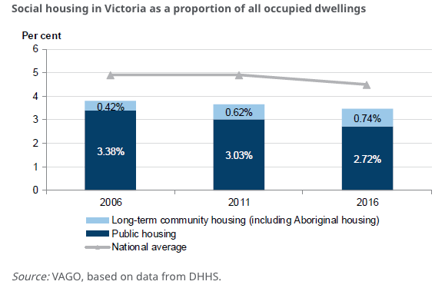

1. As we saw in Discussion Paper 2, rates of presentation for homeless assistance accelerated fast during the period to 2016 (and beyond), as the majority of the Aboriginal population exposed to a highly stressed private rental market grew by 7.5 percentage points.
2. While across the OECD social housing makes up 7% of all stock, Australia’s share languishes at 4.5% and Victoria has the least social housing of any state, now at little more than 3%.
3. The result is a long-term trend of unmet need for social housing in Victoria. As the Table below shows, only around 5% of Aboriginal people presenting in the homeless system and requiring long-term housing receive it. The proportion of unmet need has risen significantly since 2011-12, before stabilising at high levels.

***Figure 3: Proportion of Aboriginal Victorians with Long-term Accommodation Needs 2011-12 to 2020-21***

## MANA WOORN-TYEEN MAAR-TAKOORT POLICY FRAMEWORK: PROPOSED ACTIONS AND STATUS

1. Objectives 2.2 and 2.3 of the Framework were to “Build 5,000+ social housing properties by 2036 – 300 houses pa” and “Meet supply needs for transitional and (crisis) short term and special needs housing.”
2. Following the launch of the Framework, the Victorian Government announced the first significant expansion in social housing supply in a generation, committing to BHB of $5.4 billion and $1.38 billion BHB SHGF grants. The program seeks to build up to 4,200 Social Housing dwellings, with 10% of housing (420) across the SHGF grants program allocated to Aboriginal Victorians, in line with the Framework.
3. While very welcome, Victoria’s rate of investment remains below the national per capita average and trails decades of underinvestment. the Framework projected that an additional 5085 additional social housing units would be required by the Aboriginal community between 2016 and 2036, just to maintain the proportion of the existing population in social housing.
4. The number of Aboriginal Victorians on the Housing Registrar waiting list has grown by more than 2,000 between June 2019 and March 2022 alone (from 4324 to 6349), underscoring the conservatism of our estimates.

***Figure 4: State and territory total spend on social housing per capita***

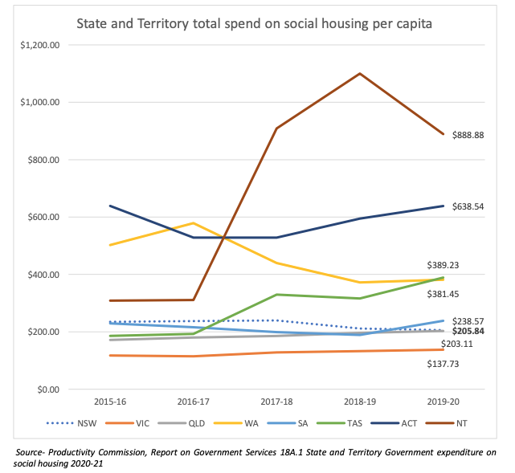

**Source:** <https://www.csi.edu.au/media/uploads/social_housing_in_nsw_contemporary_analysis.pdf>

1. A long-term pipeline of social housing is urgently required. Of the highly rationed new public housing lettings coming on line each year, Aboriginal Victorians are accessing around 12% of new lettings as the table below shows. Around 7% of new lettings in mainstream community housing went to Aboriginal families in 2020-21 and this share has grown since the Framework was launched, but remains below our share of the homeless population (around 11%).
2. Efforts by the state to secure new revenue streams for social housing, through developer contributions and waiving council rates for social housing have been frustrated by opposition from vested interests, and apparently abandoned as Government policies in the short-term.
3. Despite serious effort by the sector and the Government, the challenge to secure an ongoing resource stream for social housing has still not been achieved. Without it the rate of Aboriginal homelessness will not reduce by 10% each year in line with the Framework target, but instead will continue to grow.

***Figure 5: Aboriginal Share of New Public Housing Lettings in Victoria and Australia, 2016-17 to 2020-21***

## POSSIBLE NEXT STEPS (5-YEAR OUTLOOK)

1. Continue advocacy to secure a new pipeline of investment in social housing on a scale to arrest rising homelessness.
2. Step up efforts to secure a larger share of mainstream community housing units for Aboriginal families.
3. Explore joint housing development ventures with mainstream social and private providers.
4. Pursue rate relief on a Council by Council basis (rebates are allowable under the Local Government Act) and invest savings in more housing.
5. Encourage the Government to achieve a revenue stream by taxing foreign investment in residential housing (mirroring schemes operating in Singapore and Hon Kong).
6. Pursue opportunities to build social housing on unused Aboriginal land through partnership ventures with philanthropy.
7. Persuade the Government to agree to designate a proportion of Aboriginal social housing when selling vacant land to developers.
8. Pursue a new investment deal in social housing as an arm of Treaty negotiations.

# Discussion Paper 4

Private Rental

## THE CHALLENGE

1. Those locked out of home ownership and social housing rely on a crowded private rental market where competition is fierce. More and more Aboriginal Victorians find themselves in this market.
2. By 2016, 36 per cent of Aboriginal Victorians were living in the private rental market (up from 28-30 per cent a decade earlier).
3. The AIHW has shown that, by 2016, 41 per cent[5] of renting Aboriginal households living in Victoria were in housing stress, up from around 22 per cent[6] in 2001 and we can be confident things have not improved since then.

***Figure 1: Rise in Private Rental Tenure Share, 2006 to 2016 (Aboriginal Victorians Blue Bar)***

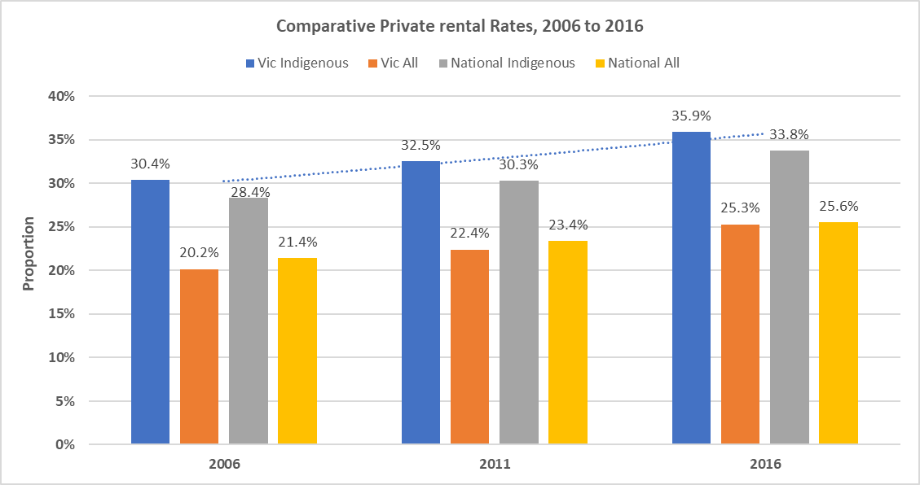

Source: AHV and Homes Victoria, *Mana-na woorn-tyeen maar-takoort 2021 Annual Report Card p.29 (ABS Census)*

1. Low incomes and racial discrimination place Aboriginal households at the end of a very long queue for scarce private rental offerings.
2. Figure 2 shows where in Victoria the largest numbers of Aboriginal Households were renting from private landlords in 2016. Many are in regional Victoria and on the city fringe where properties are least expensive, but where many of the proportionately largest cost increases have recently occurred.

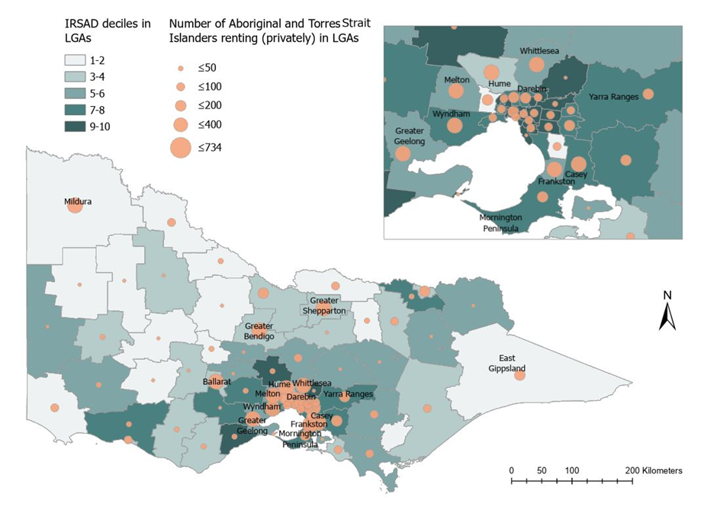

***Figure 2: Number of Aboriginal people renting from private landlords, in LGAs (Victoria) Source ABS 2016***

Source: Stone, W.M., Goodall, Z.A, Peters, A. and Veeroja, P. (2021) *Aboriginal Private Rental Access in Victoria: “Excluded from the Start”*, A Report Commissioned by the Consumer Policy Research Centre, Swinburne University of Technology, Melbourne

1. The private rental market has been saturated over the past two years, in much of regional Victoria, as many citizens escape city lockdowns and take the opportunity to work remotely.
2. To underscore the sweep of demand, the Victorian Valuer-General has shown that the number of country Victoria house sales for the first quarter of 2021 was 39.6 per cent higher than for the first quarter of 2020[7]. (13) Many of these properties are removed from the rental market as new owners move in. Because 56% of Victoria’s Aboriginal people live in rural and regional Victoria they are disproportionately displaced.
3. The number of private rental lettings affordable to people on low incomes in regional Victoria fell by 41% from 4,974 properties in the March quarter of 2019 to 2,930 properties in September 2021 as COVID migration to the regions took effect. The share of properties that were affordable in country Victoria fell from 45.2% to 33.3% during this period. See Figure 3 (below).

***Figure 3: Decline in Volume of Affordable Private Rental Lettings Regional Victoria March 2019 to September 2021***

|  |  |  |  |  |  |  |
| --- | --- | --- | --- | --- | --- | --- |
| *Part of State* | *Mar 2019* |  | *Sep 2021* |  | Decline in Share Affordable | Decline in Number Affordable |
|  | ***Affordable*** | ***Percent*** | ***Affordable*** | ***Percent*** |  |  |
| *All Non-Metro* | ***4,974*** | ***45.2%*** | ***2,930*** | ***33.3%*** | 12.20% | 41.1% |

Source: Victorian Government data directory: Rental Report: Quarterly Affordable Lettings by LGA September 2021

1. This crash in affordability has impacted people on income support and minimum wages hard as the chart below from the Anglicare Annual Housing Affordability for March 2021 shows.

***Figure 4: Decline in Volume of Affordable Private Rental Lettings in Australia March 2020 to March 2021***

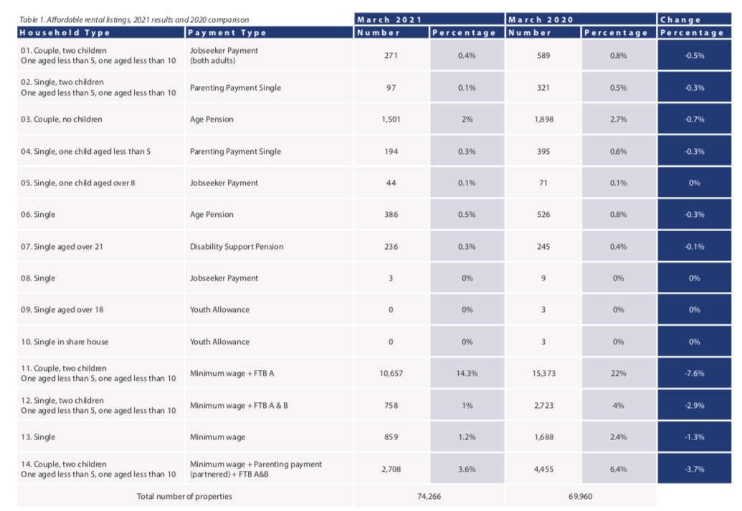

1. Experiencing double the mainstream rate of unemployment[8] increases Aboriginal exposure to meagre levels of income support. The lowest rates of income support for unemployed people in the OECD have seen the rental purchasing power of Newstart erode year on year for the past decade and longer. After a brief holiday from poverty, Newstart rates were reset to breadline levels unrivalled in the OECD in early 2021 as the table below shows. Over 80% of Aboriginal people who presented to homeless services in 2020-21 were dependent on Commonwealth income support and 13.2 had no income at all[9].

***Figure 5: Unemployment benefit net replacement rate, 2020 or latest year***

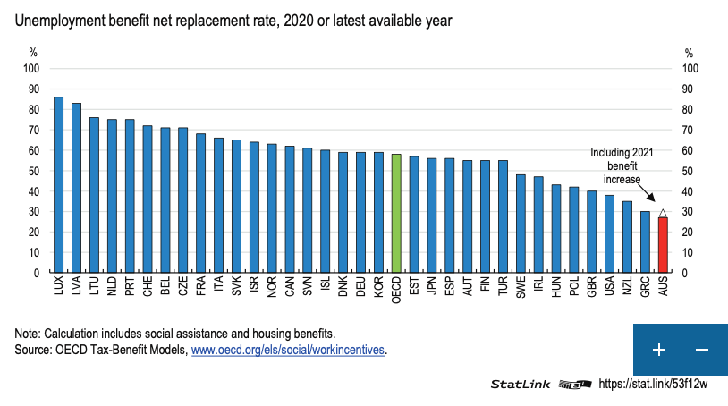

Source: OECD Economic Surveys Australia 2021, p.36

1. These trends mean Aboriginal people require far greater assistance in the rental market now than they did at the time of the last Summit in 2019.

|  |
| --- |
| **Commonwealth Rent Assistance: Time to Catch Up**  Two-thirds of low income renters are in housing stress. Productivity Commission calculations suggest the number of private renters in housing stress has [doubled over the past two decades](https://www.pc.gov.au/research/completed/renters/private-renters.pdf), largely because rent assistance has failed to increase in line with rents.  Rent assistance is at present added on to other payments such as the pension and JobSeeker and is inadequate. Jessica Irvine in the Age put the problem this way in May 2022 – “Rent assistance is paid at a rate of 75 cents in every dollar in rent paid above a certain rent threshold, up to a maximum amount of $145.80 a fortnight for a single person with no children. The problem is both the rent threshold and maximum amounts are indexed to rise with consumer price inflation only, and not rents. According to a Productivity Commission analysis, consumer prices have increased 75 per cent since 1996, but actual rents have almost tripled during this time. If the 1995 rate of rent assistance had risen with actual rents, it would be closer to $210 today.”  Calculations undertaken for AHURI by Rachel Ong, Chris Martin, Hal Pawson and Randjod B Singh, found [one-third](https://www.ahuri.edu.au/__data/assets/pdf_file/0019/65422/AHURI-Final-Report-342-Demand-side-assistance-in-Australias-rental-housing-market-exploring-reform-option.pdf) of the people who get it remain in housing stress even when assisted and many people in housing stress don’t receive the payment because they are not in receipt of Commonwealth income support payments.  Renters in community housing are eligible to receive rent assistance, while those in public housing are not. Rent assistance, while inadequate, nevertheless helps to maintain the viability of community housing.  There is near universal agreement that rent assistance is inadequate at its current level. The Conversation reports that the Australian Council of Social Service wants a [30%](https://www.acoss.org.au/wp-content/uploads/2020/02/FINAL-ACOSS-Budget-Priority-Statement-2020-2021.pdf) in increase in the maximum rate of rental assistance. The Grattan Institute has called for a [40%](https://grattan.edu.au/wp-content/uploads/2019/04/916-Commonwealth-Orange-Book-2019.pdf) increase and even the Productivity Commission wants a [15%](https://www.pc.gov.au/inquiries/completed/human-services/reforms/report/human-services-reforms.pdf) increase to restore what’s been lost over the past decade.  Ong, Martin, Pawson and Singh have estimated that raising the maximum rate of Commonwealth rent assistance by 30 per cent would almost halve housing stress in the private rental market. It would cost around $1 billion per year to the cost of the program. |

## MANA WOORN-TYEEN MAAR-TAKOORT POLICY FRAMEWORK: PROPOSED ACTIONS AND STATUS

1. Sections 3.1 and 3.3 of Framework outlined a wide range of actions Government could take to improve Aboriginal people’s experience in the private rental market.
2. The Government took two of these actions up.
3. The first was to work with the Residential Tenancies Commissioner to investigate apparent discrimination against Aboriginal people in the private rental market. A Report has been prepared and the Commissioner (with input from members of the Framework Implementation Working Group) has made recommendations to the Minister for Consumer Affairs. Further action is pending.
4. The second was the funding of a two-year $4.2m Aboriginal Private Rental Assistance Program (APRAP), to underpin the launch of Framework.
5. The aim of the APRAP is to prevent or end homelessness by rapidly rehousing people in private rental, particularly assisting people in crisis, transitional or social housing to become independent in the private rental market.
6. Commencing late 2020 APRAP has assisted 187 Aboriginal households (at March 2022) from across five regions, assisting 82.4% of those who sought help.

## POSSIBLE NEXT STEPS (5-YEAR OUTLOOK)

1. The temporary and short-term APRAP pilot program has demonstrated efficacy and should now be funded state wide, at scale.
2. The Government should implement recommendations from the Residential Tenancies Commissioner to tackle discrimination in the private rental market.
3. Other Framework proposals not yet adopted by Government should also inform next steps.
4. There is an urgent need to create sustainable opportunities for ethical investment in affordable build to rent schemes. This includes income and land tax concessions for affordable rental investment, including institutional investors. Without these major changes housing stress in the rental market will continue to push people into homelessness.
5. We should be seeking to provide training opportunities for more Aboriginal real estate agents to reduce racial discrimination in the private rental market.
6. Greater legal protection is needed for tenants who are vulnerable to eviction. Framework advocated for a Koori-list at VCAT for tenancy dispute hearings. Around 40% of people seeking homeless assistance are facing a housing crisis often resulting from eviction and few evictions are contested

# Discussion Paper 5

Home Ownership

## THE CHALLENGE

1. Aboriginal people’s rates of home ownership are more than 20 percentage points lower than other Victorians – a result of intergenerational economic exclusion.

***Figure 1: Comparative Rates of Aboriginal and Other Home Ownership, 2006 to 2016***

1. The time when Aboriginal people were finally given the opportunity to participate economically coincided with a period when the cost of buying a house has moved out of reach of most ordinary wage earners unless they have financial assistance or an inheritance.
2. In early 2020 as the Framework was released, we had high hopes of the property market finally moderating, after two decades of large price rises.
3. One month later COVID hit Victoria and the RBA reduced interest rates to the lowest levels in Australian history. The resulting sugar hit to borrowing costs, coupled with a desire by many to lock down in spaces we like and control, set the buyer market on fire and drove prices further out of reach for many Aboriginal Victorians.
4. Over the 12 months to September 2021 alone, the median house price in country Victoria increased by 22.4 per cent from $412,500 to $505,000. In Metro Melbourne the median price had soared to $850,000 by September 2021 (Valuer-General). The Domain House Price Reports cites even higher median prices, including a median above $1m for Melbourne houses. (See Figure 1 below)
5. Demographia International uses a price-to-income ratio of the median house price divided by the gross median household income to measure affordability. According to this measure, Melbourne is now the fifth most expensive city in the world to buy a home. Housing markets with a median multiple above 5 are regarded as seriously unaffordable. The Melbourne median multiple rose steadily from 4 in 1996 to 9 by 2019. During the period from 2019 and 2021 the median multiple in Melbourne soared from around 9 to above 12, shifting the market from seriously unaffordable to prohibitive to all but the best resourced purchasers.
6. Of the major city markets measured by Demographia, **Melbourne suffered the eighth largest deterioration in affordability from pre-pandemic to post pandemic levels**, as the years taken to save for a deposit increased by 2.6 in just two years.

***Figure 1: World Cities with the Largest Housing Affordability Deterioration 2019 to 2021***

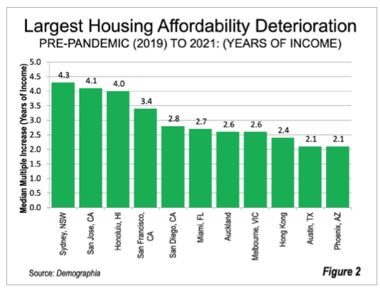

1. The average loan for an established house in Victoria is now at a record high of $675,700 (The Age 2 March 2022), having risen $147,200 or 27.9% since February 2020. CoreLogic’s research director, Tim Lawless, says house “prices have risen almost 11 times faster than wages over the past year”[10].
2. Tables from the Victorian Valuer-General show the steepling rises in Victorian real estate since the COVID pandemic. While international comparisons focus on major cities, the increases in housing costs in Regional Victoria have outpaced the rises in Melbourne. (see Figure 2).
3. These changes have frustrated a core objective of the Framework – to assist more Aboriginal Victorians achieve home ownership.
4. Purchasing a property at times of record prices and the lowest interest rates on record is fraught with risk. While borrowing costs are currently low, mortgages endure for decades and rates are already rising.

***Figure 3: Country Victoria: Residential Price Statistics 1990-2021 for Houses (Blue), Units (Aqua) and Vacant Land (Grey)***

# 

Source: Valuer-General Victorian Property Sales Report September 2021

## MANA WOORN-TYEEN MAAR-TAKOORT POLICY FRAMEWORK: PROPOSED ACTIONS AND STATUS

1. Objective 3.4 of the Framework was to Make home ownership available to more Aboriginal people, including by:
   1. Building aspirations for home ownership and capacity to act on them
   2. Establishing an Aboriginal end-to-end pilot support program to increase home ownership (shared equity home purchase; special financing; loan vehicles and advice; and related support to enter the market)
   3. Establishing rent to buy schemes for Aboriginal people
2. Despite extensive modeling by AHV and discussions with the Department of Treasury and Finance, and promises in the 2020 Victorian State Budget, an Aboriginal shared equity program for home ownership has not been established by the Victorian Government.
3. Other the Framework recommendations to advance home ownership have also languished.

## POSSIBLE NEXT STEPS (5-YEAR OUTLOOK)

1. Recommended actions from the Framework that have not been progressed should take priority.
2. Establish an Aboriginal-specific shared equity program or provide strong pathways to mainstream programs where the Government pays part of the deposit and retains a share of equity in homes owned by Aboriginal Victorians (removing the need to save a large deposit in order to get a foot on the property ladder).
3. Create an integrated, end-to-end package of support to assist Aboriginal people enter the housing market, building on the foundations of the proposed shared equity program. Home Start in SA provides a sound model.
4. Work with Government and the philanthropic sector to create more ambitious rent to buy housing developments, where Aboriginal people can build equity in a property, initially through renting. Such models do exist on a small scale in Victoria, but none are dedicated to Aboriginal housing.
5. Advocate for an end to negative gearing, which allows investors an unfair competitive advantage over owner-occupiers in being able to offset net rental loss against other income earned in a way not available to people seeking to buy a home for shelter.
6. Advocate to introduce a tax offset on borrowing costs for owner-occupiers on low incomes, based on the US taxation model.

# Discussion Paper 6

Housing Young People at Risk

## THE CHALLENGE

1. In 2020, Aboriginal children were 15 times as likely as non-Aboriginal children to be on care and protection orders in Victoria.[11]
2. Each year in Victoria around 80 Aboriginal young people leave the out of home care system. Many subsequently become homeless. By way of example, Figure 1 (below) reveals the breakdown of Aboriginal care leavers by placement type over the three years from 2015 to 2018.

***Figure 1: Aboriginal Children Exiting Care 1 July 2016 to 30 June 2018***

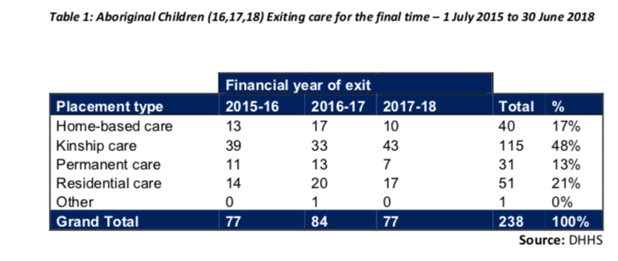

1. In a report released on 2 April 2020 – *Children at the Intersection of Child Protection and Youth Justice Across Victoria* – it was revealed that 1938 of 5063 (or 38%) of all children and young people sentenced or diverted in the justice system in the calendar years 2016 and 2017 had been the subject of a child protection report. Of these only 2 per cent had contact with the justice system before coming into contact with the child protection system. The same report found that the more carers a child had the more likely they were to appear in court.
2. Aboriginal children are vastly over-represented in both out of home care and juvenile justice systems, often setting them on a path toward truncated, trauma-filled lives. But safe, secure housing options could help break these cycles. Carers and case managers know this.
3. To end the clear intersection between entering and exiting OOHC, child protection services and contact with the criminal justice system, housing insecurity for Aboriginal young people and their parents needs to be addressed.
4. The State Government’s Beyond 18: Longitudinal Study on Young People Leaving Care revealed that those closest to children transitioning from care (carers and case managers) identify safe and affordable housing as the single most critical need these young people have as Figure 2 clearly illustrates.

***Figure 2: Carer and caseworker perceptions of care leavers’ most important needs***

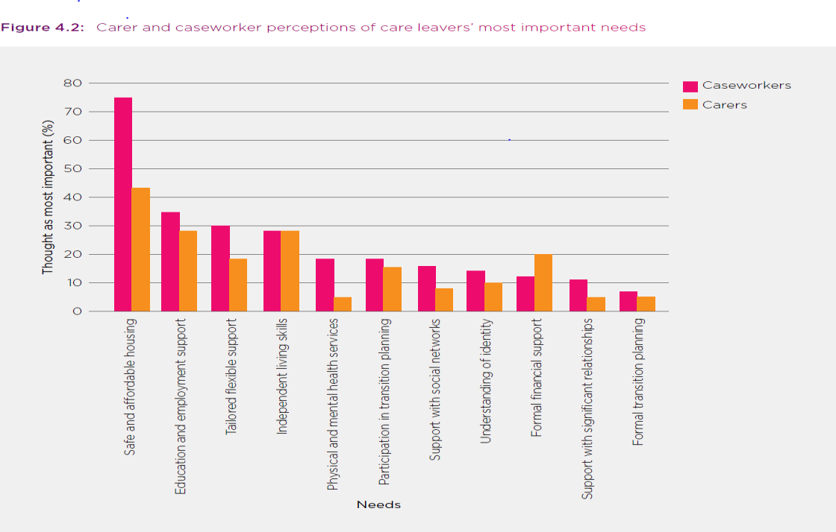

**Source:** *Beyond 18: Longitudinal Study on Young People Leaving Care* 4

1. Despite this, housing is the need least likely to be met. It appears that most of these young people present in the homelessness system after leaving care, making up around 2% of SHS clients, as Figure 3 shows.

***Figure 3: Indigenous SHS clients aged 20 or under leaving care in Victoria 2011-12 to 2020-21 as a proportion of all SHS clients***

1. Comparing Figures 1 and 3 for example we can see that 77 Aboriginal young people left care in 2017-18 (Figure 1) and 61 care leavers presented as clients of the specialist homeless support system in the same year (Figure 3).
2. This deficit in safe, affordable housing options is continuing despite the clear risk of incarceration, drug dependency, early unplanned pregnancies (resulting in child removal) and homelessness of failing to provide adequate housing to young people exiting care.
3. *Finding 20* of the 2021 *Our Youth Our Way* Report by the Aboriginal Youth Commissioner was that: *“A significant proportion of Aboriginal children and young people in the youth justice system experience housing insecurity. For some young people, insecure housing and involvement in the youth justice system are directly linked. Supported accommodation can assist these young people to stay out of the youth justice system.”*
4. Of all of the home seekers appearing in the SHS system young singles are amongst the least likely to be able to be assisted. There are many reasons for this:
   1. They usually lack employment (the second highest need after housing identified by carers in the surveys cited above is a job)
   2. Neither Jobseeker payment nor Youth Allowance provide income capable of buying rental accommodation anywhere in Australia.
   3. There is a shortfall in the provision of 1 bedroom units in the profile of social housing because these are the most expensive to build and subject to the highest demand.
   4. Mothers with dependent children leaving family violence are given priority over single young people in social housing.
   5. Few models are funded in Victoria where sufficient wrap around support can be provided to a young person lacking life skills to maintain a tenancy – the Housing First Model which has proven successful in many jurisdictions is largely non-existent in Victoria. (See Attachment 1 for existing support models.)
   6. These young people, in addition to lacking adequate income, often have no rental history to compete in the private market.
   7. Few niche models are available to young singles – Youth Foyers for example only provide for 236 beds statewide (tenure is for a maximum of 2 years) and some care leavers and ex young offenders are disqualified even from these limited offerings.
   8. These young people often have few adult advocates despite the ACCOs, which work heroically to assist them against great odds.

## MANA WOORN-TYEEN MAAR-TAKOORT POLICY FRAMEWORK: PROPOSED ACTIONS AND STATUS

1. Action 1.2.2 of the Framework proposed that “Intensive, culturally appropriate structured case managed approaches drawing in relevant specialist service supports must be sustained and based on need. Those at high risk must receive specialist and intensive housing, community support and pathways, including those experiencing:
   1. Mental health
   2. Drug and alcohol
   3. Family violence – victims and people who choose violence
   4. **Leaving out of home care (at least 5 years) and/or**
   5. Contact with and leaving the justice system.
2. Action item 4.2.2 of the Framework proposed that Government “Provide tailored and targeted support for those at high risk– provide housing, support and pathways for leaving out of home care, leaving justice system.”
3. This kind of housing underpinned by intensive support services has not been put in place for vulnerable young Aboriginal people, despite AHV’s strong advocacy through relevant commissions and inquiries.

## POSSIBLE NEXT STEPS (5-YEAR OUTLOOK)

1. The *Our Youth Our Way* Report included two Recommendations to Government related to Housing for young people. These were:
   1. That the Victorian Government establish Aboriginal community-controlled crisis accommodation for Aboriginal children and young people in every region, informed by the model provided by Nungurra Youth Accommodation Services. (Recommendation 43)
   2. That the Victorian Government establish at least 4 Aboriginal community-controlled youth foyers across the state, with consideration given to 3 regional locations and one metropolitan location. (Recommendation 44)
2. The following Principles should be considered in working with young people leaving care.
   1. All young people leaving care or youth justice and protective services facilities should  have a leaving care plan.
   2. Affordable, long-term housing should be at the apex of all leaving care plans.
   3. Support services must be ongoing for young people as they leave care.
   4. Family – Culture – Community: these are what keep Aboriginal people strong. If family  is missing, culture and community must step in.
   5. Young people should not be “turfed out” of care early and extended care should be  pursued wherever possible.
   6. It is essential for the community to create relationships with young people before they  leave care. The system should support and facilitate this.
   7. Getting young people back home before they reach the age of 18 should be an  aspiration.
   8. Leaving care plans should include a cultural component, including returning to  country.
3. The option to support care leavers to age 21 (*The Final Stretch*) should be available to all young  Aboriginal people who seek this option.
4. There are some other small scale programs with potential to assist young people leaving care. An overview of these (including their target participants, scale and bed capacity) is included in a table at ***Attachment 1***. A number of these have merit and require greater scale. However, almost none of these housing options are long term, almost all are transitional.
5. More funding for community and affordable housing is critically needed.
6. Medium-term/transitional housing is critically needed in the short-term to allow other crisis responses to kick in.
7. Aboriginal organisations delivering the Aboriginal Leaving Care program require adequate support and to be linked with housing providers who can meet the accommodation needs of the young people they are attempting to assist. Due recognition is required that they are working with some of the most vulnerable young people in our state, many with complex needs and challenging behaviours.
8. Rental brokerage programs can be a useful model for this cohort, in which an adult advocate or support worker brokers a private rental for the young person and supports them to maintain the repayments acting as the liaison with the landlord. This model could be expanded and coupled with greater interpersonal support and coaching provided to the young tenant.

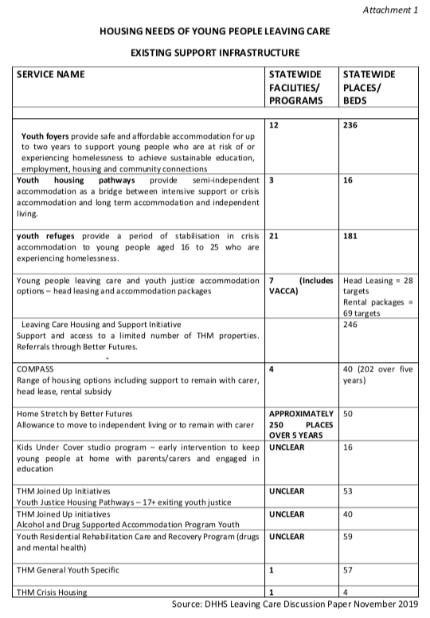

# Discussion Paper 7

Elders’ Housing

## THE CHALLENGE

1. The population of Elders in Victoria is forecast to grow by 66% between 2021 and 2036 (see Figure 1), based on demographic forecasts prepared for AHV by Dr Noor Khalidi.
2. From 2023 all members of the Stolen Generations in our state will be over 50 years and requiring culturally safe, trauma-informed care.
3. As a state we appear wholly unprepared for these changes.

***Figure 1: Forecast Increase in Aboriginal Elders in Victoria***

|  |  |  |  |  |
| --- | --- | --- | --- | --- |
| Age Groups | 2021 | 2026 | 2031 | 2036 |
|  | | | | |
| 60-64 | 1980 | 2302 | 2710 | 2697 |
| 65-69 | 1502 | 1781 | 2084 | 2472 |
| 70-74 | 995 | 1268 | 1515 | 1796 |
| 75+ | 938 | 1229 | 1593 | 2006 |
| **TOTAL** | **5415** | **6580** | **7902** | **8971** |

1. While the aged care sector has been placed under inordinate pressure by the COVID pandemic, the most recent Royal Commission made clear that it was already a system under enormous stress. The pandemic ruthlessly exposed these weaknesses as aged care facilities became the sites of the highest death rates wrought by COVID in Australia.
2. Productivity Commission Reports consistently find that Aboriginal people are less likely than any other cohort to receive the aged care assessments which trigger support packages and entry into the supported aged care system.
3. Unlike many CALD groupings, culturally specific aged care offerings are largely absent for Aboriginal Elders. We are aware of only two Aboriginal specific aged care facilities in Victoria (one in Brunswick and one in Shepparton).
4. This was already a problem identified at the 2019 Summit and further investments by Government have not been made.
5. Imminent future growth in the seniors population makes the need for the development of culturally safe aged care urgent.
6. Rising rental prices, particularly in regional Victoria, coupled with the sale of rental properties in the recent housing boom, are pushing increasing numbers of Elders into homelessness.
7. As Figure 2 shows Aboriginal people in Australia carry an unequal burden of morbidity. They are far more likely to develop disabilities as they age and these arise at earlier ages, reinforcing the need for care and support. The community is carrying this burden as, despite higher levels of need, Elders are receiving lower levels of access to aged care support than other seniors.

***Figure 2: Disability Rates by Age and Status, 2012 and 2015, ABS 4430.0***

# Macintosh HD:Users:peterjones:Desktop:Screen Shot 2022-03-17 at 2.21.58 pm.png

## MANA WOORN-TYEEN MAAR-TAKOORT POLICY FRAMEWORK: PROPOSED ACTIONS AND STATUS

1. Action 1.2.1 proposed that “Clients be supported to navigate integrated housing support pathways and access points…”
2. Action 1.2.2 of the Framework proposed that “Intensive, culturally appropriate structured case managed approaches drawing in relevant specialist service supports must be sustained and based on need. Those at high risk must receive specialist and intensive housing, community support and pathways
3. Action 2.3.2 dealing with special needs housing proposed that “**Needs of Elders and clients with disabilities be addressed through special purpose developments.**”
4. Governments have failed to invest in the kinds of special purpose developments for Elders in Victoria advocated by the Framework.

## Macintosh HD:Users:peterjones:Desktop:Screen Shot 2022-03-17 at 3.11.23 pm.png

## Source: Aged Care Royal Commission (March 2021)

## POSSIBLE NEXT STEPS (5-YEAR OUTLOOK)

1. There is a critical need for special purpose developments of Aboriginal owned and managed aged care facilities where Elders can be assured of a culturally safe level of care. Implementation of chapter 7 of the Aged Care Royal Commission would achieve this.
2. Recommendations of the Aged Care Royal Commission (March 2021) should be implemented urgently in Victoria, where these pertain to Elders, with particular reference to Chapter 7 entitled “Aged Care for Aboriginal and Torres Strait Islander People”. In particular:
   1. As Recommended, a guiding Principle of the administration of the Aged Care Act should be that “Aboriginal and Torres Strait Islander people are entitled to receive support and care that is culturally safe and recognizes the importance of their personal connection to community and Country.” (Reco 3bxii)
   2. As Recommended the Aged Care Commission should have as a core responsibility “ensuring that appropriate aged care services are widely available for Aboriginal and Torres Strait Islander peoples.” (Reco 3cvi)
   3. As Recommended, the Aged Care Commission should include an Aboriginal Torres Strait Islander Commissioner (Reco 4f)
   4. All Recommendations of Chapter 7 of the Aged Care Royal Commission (Recommendations 47-53) should be actioned. These propose reforms to create an effective Aboriginal Aged Care system in Australia, enabling ACCOS to become aged care providers, establishing training and employment opportunities, creating discrete funding streams for ACCOs and building safe, accessible pathways into care for Elders.
3. The Aged Care Recommendations, if implemented would address the need for Aboriginal trained advocates who can facilitate aged care assessments and overcome threshold, gate-keeping barriers to aged care services.
4. All aged care facilities should have cultural safety plans in place to ensure they have the skills to care for Elders, particularly Stolen Generations, in keeping with Aged Care Royal Commission Recommendation 3bxii.

# Discussion Paper 8

Housing People Exiting Corrections

## THE CHALLENGE

1. Prisons have become de facto housing for too many homeless Aboriginal people.
2. In 2011-12 exiting prisoners made up 5% of the Aboriginal people presenting for homeless support in Victoria. By 2020-21 it was 12% - 935 people. This means more than one in ten Aboriginal people seeking homeless assistance in our state are leaving prison.

***Figure 1: Aboriginal People Exiting Custodial Settings into the Specialist Homeless Support System 2011-12 to 2020-21***

Source: Australian Institute of Health and Welfare

1. Criminalisation of Aboriginal people has become an accelerating driver of growing rates of Aboriginal homelessness in Victoria. Doherty and McNicol from Elizabeth Morgan House report that “half of all women exiting prison expect to be homeless on release.”[12]
2. Changes to the *Victorian Bail Act 1977* introduced in 2018, shifted responsibility for justifying bail to the offender. Bail, like parole, is regularly denied if prisoners have no fixed address, leading to an increase in sentenced and unsentenced Aboriginal people. [13] These new bail conditions also now apply to low level offences, drawing more Aboriginal women into the net of those incarcerated without conviction.[14]
3. These reforms have been enormously and predictably damaging to Victorian Aboriginal families as more and more women are held on remand, unable to provide a stable presence in the home for their children.[15] These retrograde policies drive more and more Aboriginal children into out of home care (OOHC) where their risk of future homelessness is dramatically increased, as demonstrated in Discussion Paper 6.
4. Lack of appropriate housing after prison drives reoffending as prisoners who are homeless upon exiting prison return in greater numbers.[16] On release it acts as a barrier to reunification with children, the absence of stable housing keeping children and parents apart as children are left languishing in child protection and out-of-home-care (OOHC) services.
5. The diagram below depicts the recidivism roundabout created for the Victorian Aboriginal Community by derelict Government policies. If stable housing with integrated support was provided after any stage in the roundabout where an individual exits an institutional setting, it would be possible to get off and high recidivism rates would recede.
6. Not only is the human cost of imprisonment devastating for Victorian Aboriginal families, it constitutes an avoidable financial cost burden for the Victorian community. Supported housing for Aboriginal people would pay dividends for the people and for the wider community.
7. In Victoria in 2019-20, the net operating expenditure per prisoner per day was $323.45. [17] Therefore, it costs $118,059.25 to keep an Aboriginal person convicted of a non-violent crime in prison each year.
8. 300% more than it costs to support the same person in a residential scheme.[18]
9. Almost 500% more than the cost of post-release accommodation, with wrap-around support, including drug and alcohol, mental health, childcare and parental skills, and assistance with employment/training with the option of permanent housing.[19]

***Figure 2: The Recidivism Roundabout***

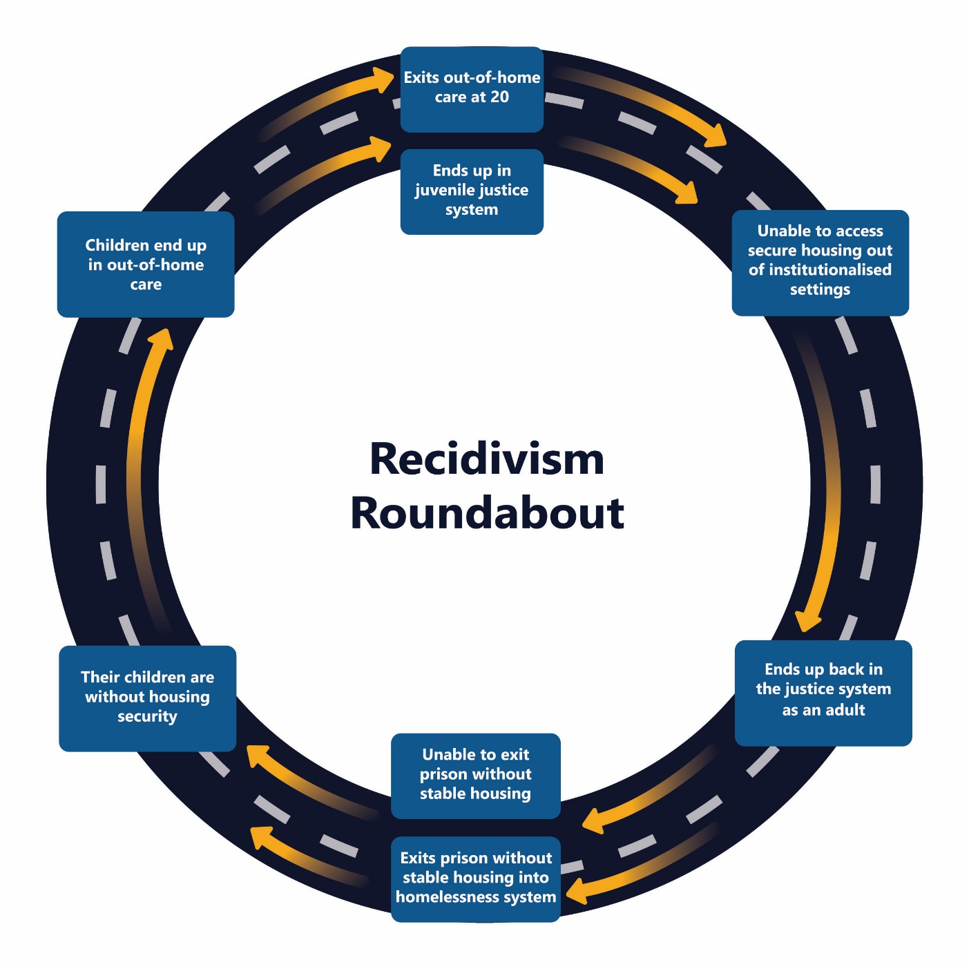

1. Governments are also increasingly unlikely to meet demand for alcohol and drug counseling for homeless people. Unmet need for these services has almost doubled from around 23% a decade ago to over 40% last year. These failures are extending periods of homelessness and driving more Aboriginal people into the justice and corrections systems.
2. The same pattern of rising failure is evident for unmet demand for mental health services for homeless Victorians, with more than 40% of Aboriginal Victorians denied assistance.
3. For these programs to be effective, they need to be delivered to people whose housing has been secured, in keeping with the Frameworks Housing First Principle.

***Figure 3: Levels of unmet need for drug and alcohol counseling for Homeless Victorians by Indigenous Status***

***Figure 4: Levels of unmet need for mental health support for Homeless Victorians by Indigenous Status***

## MANA WOORN-TYEEN MAAR-TAKOORT POLICY FRAMEWORK: PROPOSED ACTIONS AND STATUS

1. Action 1.2.2 of the Framework proposed that “Intensive, culturally appropriate structured case managed approaches drawing in relevant specialist service supports must be sustained and based on need. Those at high risk must receive specialist and intensive housing, community support and pathways, including those experiencing:
   1. Mental health
   2. Drug and alcohol
   3. Family violence – victims and people who choose violence
   4. Leaving out of home care (at least 5 years) and/or
   5. ***Contact with and leaving the justice system.***
2. Action item 4.2.2 of the Framework proposed that Government “Provide tailored and targeted support for those at high risk– provide housing, support and pathways for leaving out of home care, leaving justice system.”
3. Unfortunately, significant progress has not been made in improving stable, long-term supported post-release housing for Aboriginal prisoners, many of whom are dealing with mental health issues, drug and alcohol issues, family violence and children in care, in addition to the trauma of incarceration.

## POSSIBLE NEXT STEPS (5-YEAR OUTLOOK)

1. The Victorian Government needs to urgently adjust its whole of Government policy priorities to increase access to housing for people trying to exit the justice system. Doing so would improve community safety, achieve cost savings for the Victorian community and begin to remove the shame to our state of Victoria’s First Nations People being amongst the most incarcerated people on earth.
2. A Housing first approach is required for post-release prisoners. Without housing, other support services have limited long-term traction.
3. Solutions to the housing crises that Aboriginal community is currently facing in Victoria, must seek to put in place integrated, wrap around supports for those trying to put their experience of incarceration behind them.
4. This requires new models of investment, which bring together capital investment in accommodation and culturally appropriate, structured service supports that can make the accommodation sustainable.
5. In the short-term, new transitional and emergency housing options are urgently needed to respond to the immediate deficit in housing which is driving people back into youth justice and prison settings.
6. Reform to Bail laws that incarcerate as a first rather than last resort are urgently needed.

# Discussion Paper 9

Family Violence and Housing

## THE CHALLENGE

1. Despite very positive reform and significant investment by the Victorian Government, and strong leadership by the Victorian Aboriginal community, family violence remains the single biggest presenting issue for Aboriginal people experiencing homelessness in Victoria. Forty one per cent of presentations (4,435 people) to specialist homeless support services by Aboriginal Victorians in 2020-21 related to family violence.
2. Since the Victorian Government’s commitment to recommendations in the Royal Commission into Family Violence in 2016, the response to Aboriginal people from homeless services for family violence support has improved. This is the only measure for which unmet need for crisis support has improved in recent years, highlighting the importance of committing to a plan and sustaining investment to lift outcomes. However, a critical shortage of Aboriginal specific refuges remains.

***Figure 1: Proportion of unmet need for family violence services for Victorians presenting to homeless services***

1. Our state performs well in responding to immediate family violence crisis but the need for sustained housing support with trauma-informed wrap around services remains a critical gap.
2. The better integration evident in the family violence service system is not yet evident in the emergency housing and social housing systems.
3. Poverty is often the antecedent and provides the intersection between family violence and homelessness. Addressing poverty in the community is a major challenge.
4. Men’s violence is driving children into out of home care. Reducing male violence is fundamental.
5. Many women are having children removed because they are homeless victims of violence. Fear of losing children often deters women from leaving violent relationships
6. Aboriginal women are the fastest growing cohort of the prison population. Most of these women are also survivors of family violence.
7. Safety risks are amplified in regional areas, in part because opportunities to safely leave an abusive relationship are more limited.
8. Family violence is linked to the experience of very young people becoming pregnant.
9. The high cost of housing is increasingly driving displacement of people from their support communities. This makes them more vulnerable to family violence and makes escaping a violent relationship more difficult.
10. The absence of affordable, stable housing is driving women back into violent relationships extending their exposure to violence and placing children at sustained risk.
11. Family violence is more than intimate partner violence. It can include extended family and violence directed at parents.
12. The service deficits in culturally-specific support remain profound. Elizabeth Morgan House remains the only high-security refuge for Aboriginal women in the state of Victoria with accommodation for just four families. One additional high security refuge is set to open in 2022 and two low security refuges exist.[20]

## MANA WOORN-TYEEN MAAR-TAKOORT POLICY FRAMEWORK: PROPOSED ACTIONS AND STATUS

1. Action 1.2.2 of the Framework proposed that “Intensive, culturally appropriate structured case managed approaches drawing in relevant specialist service supports must be sustained and based on need. Those at high risk must receive specialist and intensive housing, community support and pathways, including those experiencing:
   1. Mental health
   2. Drug and alcohol
   3. **Family violence – victims and people who choose violence**
   4. Leaving out of home care (at least 5 years) and/or
   5. Contact with and leaving the justice system.
2. Action 1.3.1 of the Framework proposed that AHV and social housing be used as a platform to deliver social and economic programs for Aboriginal Victorians.

## POSSIBLE NEXT STEPS (5-YEAR OUTLOOK)

* 1. Many of the recommendations from the 2019 Summit remain relevant.
  2. Critically important is more long-term supported accommodation for women and children leaving violent relationships, with housing that is well designed and flexible to meet the safety and family needs of these women and children.
  3. More Aboriginal-run refuges are required where safe, culturally embedded, holistic healing is the primary goal. This would reduce the risk of Aboriginal women returning to violent relationships.
  4. A flexible family violence funding package to enable safe relocation from dangerous relationships is a model which can work.
  5. Private rental assistance programs to assist people leaving violent relationships are also required.
  6. Perpetrators of violence also require housing when they must leave the family home. Many of these people (mostly men) require support to deal with complex issues that contribute to their violent behaviour.

# Discussion Paper 10

Housing Sector Capacity Building

## THE CHALLENGE

* 1. The Framework is built on the foundational pillar of self-determination. But the Aboriginal housing and homelessness sector requires greater scale and capacity to meet the enormous demand for social and affordable housing and homelessness support evident in all core data.
  2. Of the estimated 28,000 Aboriginal households living in Victoria in 2021, approximately:
* 2,999 are living in public housing
* 1,562 are living in AHV properties
* 444 are living in other Aboriginal community owned properties
* 413 are living in non-Aboriginal community housing (2019 figure)

for a total of 5,438[21] Aboriginal households living in some form of social housing in our state. An additional 6,349 were on the Housing Register Waiting List by March 2022. Approximately one in three of these people will be classified as ‘homeless with support’ based on recent breakdowns of Aboriginal households on the waiting list[22].

* 1. A fully realised Aboriginal housing and homelessness sector will need to be built over time. Among other focus areas, this includes challenges relating to professional governance, fit-for-purpose regulation, and workforce development and training.
  2. An immediate challenge is presented by the fact that no ACCO in Victoria (apart from AHV) has registration as a Community Housing Provider or Association. This is a fundamental impediment to accessing Government social housing funding which would allow these ACCOs to build the scale to become viable.
  3. One means of building capacity and scale is through management transfers of existing public housing stock. AHV’s annual surveys of tenants confirms that the overwhelming preference of Aboriginal social housing tenants is to have an Aboriginal landlord. Understanding the needs of its tenants, AHV is able to provide an exceptionally high level of stability in tenancies. Limiting the turnover of tenancies represents a significant cost saving.
  4. The Literature Review undertaken for *Mana-na woorn tyeen maar-takoort*found that non-Aboriginal providers constitute 97.7% of all social housing in the state (75% public and 22.7% mainstream community). This dominant share reinforces the importance of improving cultural safety in mainstream social housing as a critical project in capacity building.

## MANA WOORN-TYEEN MAAR-TAKOORT POLICY FRAMEWORK: PROPOSED ACTIONS AND STATUS

* 1. Goal 5 of the Framework included Objectives to:
  2. Create a strong and viable Aboriginal Housing and Homelessness sector (Objective 5.1)
  3. Make the mainstream housing and homelessness system culturally safe (Objective 5.2)
  4. Build a systems based partnership between the Aboriginal housing and homelessness service systems (Objective 5.3)
  5. To date, limited capacity building work with the Aboriginal controlled sector has been undertaken through the establishment of an Aboriginal Housing and Homelessness Forum (AHHF) convened and chaired by AHV. This Forum has led work to:

1. Co-ordinate a state wide program to undertake $35m worth of maintenance, upgrades and modular housing for the Aboriginal Community Controlled Organisation (ACCO) sector, including AHV.
2. Undertake financial viability assessments and analysis of ACCO housing, with a view to better understand the viability of existing stock, maintenance and management requirements and its optimum utilisation. ACCOs apart from AHV own around 330 social housing units in addition to the 1585 (approx.) owned and managed by AHV.
3. Understand and respond to critical policy issues confronting Aboriginal people with respect to their housing challenges and inform Government responses and program design.
   1. Like other aspects of the response to the Framework, this funding is small scale and short-term. Ongoing funding is required to maintain this Forum and build skill and capability.

## POSSIBLE NEXT STEPS (5-YEAR OUTLOOK)

1. Funding is required for the development of an **Aboriginal work force training and development plan**. The plan would address the need to reshape the role of housing workers to incorporate skills beyond tenancy management, including proactive life coaching and intensive case management of high risk clients in sustaining tenancies. This program would build the capacity for Aboriginal providers to become entry and referral points into the housing and homeless service system.
2. Work is required to assist ACCOs with an interest in **achieving housing registration** within existing policy settings to do so. The Government should consider fit-for-purpose registration for smaller scale ACCOs, such as exists in other jurisdictions, in keeping with recommendations of the Social Housing Regulatory Review Interim Report of late 2021.
3. **The transfer of public housing stock** is one critical platform for the development of a viable, scaled up Aboriginal housing sector in our state. To achieve this requires the Government to engage with interested ACCOs as well as AHV to enable at least some ACCOs to build the scale in their housing stocks to achieve registration and begin to trade in the market and build their portfolios.
4. **Partnerships with mainstream housing agencies**: ACCOs require assistance to put in place the organisational conditions required to partner with Housing Agencies (both AHV and mainstream providers) to provide the social housing required by their communities more immediately. The funding of grants administered by Government could twin ACCOs with mainstream housing providers to build cultural safety in mainstream providers and develop housing management and development capability in ACCOs with established housing portfolios.
5. **Build cultural safety conditions into housing registration for mainstream providers**. In keeping with advice from AHV and ACCOs, **t**he Social Housing Regulatory Review Panel has recommended, in its first Interim Report, that all social housing providers should satisfy cultural safety criteria as a condition of accreditation. The Government should revise the Regulations to implement this recommendation.

1. Productivity Commission, Report on Government Services 2022.
2. As measured by presentations to the Specialist Homeless service system by homeless Aboriginal people
3. In 2020-21, over 80% of Victorian Aboriginal people who appeared in the homeless service system were dependent on Commonwealth income support, 13.2% had no income and only 6.6% had an income from a job/business.
4. Productivity Commission Report on Government Services 2017 (see email)
5. AIHW 2019, Aboriginal and Torres Strait Islander People, A Focus Report on Housing and Homelessness, p,25
6. Ibid
7. Victorian Valuer-General 2021, Victorian Property Sales Report March 2021 quarter, p.8
8. The Victorian Aboriginal unemployment rate was 14% compared with 7% for the general Victorian population at the time of the 2016 census
9. Productivity Commission, Table 19A.29, Report on Government Services 2022
10. cited by John Collett in The Age 1 September 2021
11. Victorian Aboriginal Legal Service, *Evaluation of Balit Ngulu*, (May 2020) <https://www.vals.org.au/wp-content/uploads/2021/03/Evaluation-of-Balit-Ngulu-Final-report-1.pdf> pg. 7
12. Jo Doherty, Ella McNicol, *The Need for More Aboriginal-run Refuges*, Parity Volume 34, Issue 9, November 2021
13. Fitzroy Legal Service and La Trobe Centre for Health, Law and Society, *Constellation of Circumstances:* *The Drivers of Women’s Increasing Rates of Remand in Victoria*, (July 2020) <https://d3n8a8pro7vhmx.cloudfront.net/fitzroylegal/pages/52/attachments/original/1594001770/Constellation_of_Circumstances_Report_digital_landscape.pdf?1594001770>
14. Australian Institute of Criminology, *Indigenous women’s offending pattern: a Literature Review*, (2010) <https://www.aic.gov.au/sites/default/files/2020-05/rpp107.pdf> pg.20
15. Fitzroy Legal Service and the La Trobe Centre for Health, Law and Society, A *Constellation of Circumstances:* *The Drivers of Women’s Increasing Rates of Remand in Victoria*, (July 2020) https://d3n8a8pro7vhmx.cloudfront.net/fitzroylegal/pages/52/attachments/original/1594001770/Constellation_of_Circumstances_Report_digital_landscape.pdf?1594001770
16. Australian Institute of Criminology, Research Report, *How much does prison really cost? Comparing the costs of imprisonment with community corrections*,(2018) <https://www.aic.gov.au/sites/default/files/2020-05/rr_05_240418_2.pdf> pg. 55
17. Corrections, Prisons and Parole, *Corrections Statistics: Quick Reference,* (2020) https://www.corrections.vic.gov.au/prisons/corrections-statistics-quick-reference
18. Victorian Equal Opportunity and human Rights Commission, *Unfinished Business: Koori Women and the Justice System,* (2013) <https://www.humanrights.vic.gov.au/static/fc7bc972a0d626e08576a6f0b0f0ab55/Resource-Unfinished_business-Main_findings.pdf> pg. 3
19. Victorian Equal Opportunity and human Rights Commission, *Unfinished Business: Koori Women and the Justice System,* (2013) <https://www.humanrights.vic.gov.au/static/fc7bc972a0d626e08576a6f0b0f0ab55/Resource-Unfinished_business-Main_findings.pdf> pg. 3
20. Jo Doherty, Ella McNicol, *The Need for More Aboriginal-run Refuges*, Parity Volume 34, Issue 9, November 2021
21. Samms, Jennifer, *Review of Social Housing Regulation: Issues Related to Aboriginal Housing: An Aboriginal Consultation and Implementation Strategy*, p.6
22. AHV, Mana-na woorn tyeen maar-takoort: The Victorian Aboriginal Housing and Homelessness Framework, p.70